EXPERIMENT 2 — ASSIGNMENT 2.2
Acquisition and Imaging of Digital Evidence using FTK Imager
Name: Sujal Wasnik
Roll No.: 23015036

PART A — Acquisition of Own Pen Drive

1. Hash Values (FTK Imager Verification)
Hash Type | Computed Hash | Verify Result
MD5 | cbb3816e621871e0aa98c23a00319a0c | Match
SHA-1 | c41be83ca7f44f36c5a81f60f131c01da412c341 | Match

2. Acquisition Timeline
Event | Timestamp
Acquisition Started | Friday, 28 August 2026, 19:57:05
Acquisition Finished | Friday, 28 August 2026, 20:10:37
Verification Started | Friday, 28 August 2026, 20:10:37
Verification Finished | Friday, 28 August 2026, 20:12:11

Additional acquisition details:
- Drive Interface Type: USB
- Removable Drive: True
- Source Data Size: 15000 MB
- Sector Count: 30720000
- Image Format: E01 (Segments: evidence.E01 – evidence.E04)

3. Autopsy Verification Screenshot
The screenshot below confirms the acquired image was successfully loaded and parsed in Autopsy, with the file system tree and file listing populated correctly.
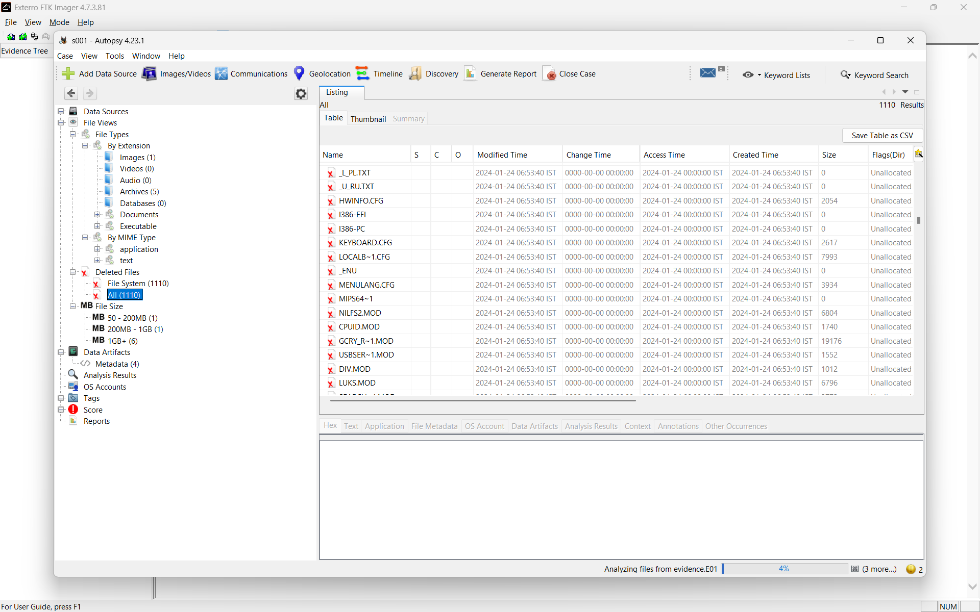

PART B — DIGITAL FORENSIC EXAMINATION REPORT
Case Exhibit: Vikrant.E01
Report Ref. No.: EXP2/PARTB/2026/23015036
Date: 29-08-2026
Compiled by: Sujal Wasnik
Roll No.: 23015036

1. Introduction (Case Introduction)
This report documents the forensic examination of the evidence image "Vikrant.E01", conducted as part of Experiment 2 (Assignment 2.2). The exhibit was analysed using Autopsy and FTK Imager to identify hidden and recovered artefacts (CTF-style flags) associated with a user account named "Vikrant Sable" present on the evidence. The objective of the examination was to identify sensitive or concealed information within the evidence without modifying the original forensic image.

1.1 Qualification and Experience
This examination was carried out by Sujal Wasnik (Roll No. 23015036) as part of coursework in Digital Forensics, using FTK Imager for acquisition/verification and Autopsy for analysis of the provided case exhibit.

2. Forensic Principles
- All analysis was performed strictly on the provided forensic image (Vikrant.E01) and its verified segments; the original evidence was never modified.
- File extraction from within Autopsy was performed in read-only mode using the "Extract File(s)" function, preserving the integrity of the source image.
- Hash values and file metadata were recorded and cross-verified where applicable to preserve data integrity.
- A logical, artefact-driven approach was used: relevant file types, deleted files, and recovered items were examined in a targeted manner rather than reviewing all files exhaustively.

3. Scope of Work
The scope of this examination was to identify three concealed flags (CTF-style markers, format CFT{...}) hidden within the evidence image through:
- Metadata and visible-text analysis of institutional PDF documents.
- Recovery and analysis of deleted files (Recycle Bin artefacts, carved/orphan files) related to a missing template.
- Recovery and visual/content analysis of a deleted image file suspected of exposing sensitive information.

4. Evidence Received

Table 1: Exhibit Details
Type | Identifier | Annexure
Forensic Disk Image (E01) | Vikrant.E01 | A

Table 2: Examination Timeline
Exhibit | Examination Started | Examination Finished
Vikrant.E01 | 28-08-2026 (approx.) | 29-08-2026

5. Analysis
Analysis was performed on the Vikrant.E01 image using Autopsy (case-based ingest and file views) supplemented by exiftool, pdftotext, and manual file review for content that Autopsy's default ingest modules do not surface directly (e.g., embedded text and image content).

Table 3: Key File Inventory
Sr. No. | File Name / Path | Nature | Annexure
1 | 53150-Nagpur_BTech_Colleges_List_2025.pdf | Institutional record PDF containing embedded flag text | A1
2 | Recovered template artefact ($Recycle.Bin) | Deleted/recovered template file containing embedded flag text | A2
3 | Users\Vikrant Sable\Pictures\Private\DSC_1048_192.png | Allocated (live) PNG in a user-created "Private" folder — corkboard photo exposing credentials | A3

Methodology summary:
- PDF documents across the exhibit were reviewed for both metadata (via exiftool) and visible text content (via pdftotext), since flags were found embedded in ordinary document content rather than in file metadata.
- Deleted Files and Carved Files views in Autopsy were used to recover a missing template artefact referenced in the case scenario; the recovered file was examined for embedded flag text.
- A smaller JPEG fragment ($RGF718W.jpg, 25,252 bytes) was initially located in an unallocated state within the $Recycle.Bin. Correlation of file size and content indicated this was a thumbnail-cache remnant rather than the source file. The corresponding full-resolution original was subsequently located as a live, allocated file at Users\Vikrant Sable\Pictures\Private\DSC_1048_192.png (1,858,937 bytes). The deliberate placement of this file inside a user-created folder named "Private" is itself indicative of an attempt to conceal the content from casual review.
- The image was extracted read-only from its allocated location and visually inspected. It depicts a corkboard containing a handwritten note exposing account credentials (Username: Vikrant123 / Password: Vikrant1763$) alongside other unrelated notes, confirming exposure of sensitive information tied to the user "Vikrant Sable".

6. Findings

Flag 1 — Institutional Document Analysis
Finding: CFT{nagpur_college_hidden_2025}
Located within the visible text content of the institutional PDF "53150-Nagpur_BTech_Colleges_List_2025.pdf", inserted between list entries and not visible without full text extraction (pdftotext), confirming the institution associated with the evidence as being Nagpur-based.

Flag 2 — Recovered Template Artefact
Finding: CFT{appr0ved_by_0perati0ns}
A template file matching the case scenario's description of a 'disappeared' document was located among recovered/deleted artefacts. Upon extraction and content review, the embedded flag text was identified within the recovered file, confirming the file had been deliberately deleted and subsequently recovered from the evidence image.

Flag 3 — Exposed Credentials in Private Folder
A thumbnail-cache fragment ($RGF718W.jpg) was first located in an unallocated state within the $Recycle.Bin, which led to identification of its full-resolution source file. The source file, DSC_1048_192.png, was found to be a live, allocated file located at:
Users\Vikrant Sable\Pictures\Private\DSC_1048_192.png
Property | Value
MD5 | 3d40fb38694bd33e1e90cbe5a929b58e
SHA-256 | 19086cccef707fa387837d9aa8a54229adee3de5276813ac8da7d92f0dbffb1a
File System Status | Allocated (live file)
Created | 2026-08-08 15:43:26 IST
File Modified | 2025-06-18 09:30:00 IST

The deliberate placement of this image inside a folder named "Private" — rather than a standard Pictures location — is itself notable and supports the challenge's framing of information that "should never have been exposed." Visual inspection of the image revealed a photographed corkboard containing a handwritten note reading:
Username: Vikrant123
Password: Vikrant1763$
This constitutes clear exposure of sensitive account credentials associated with the suspect user "Vikrant Sable", satisfying the challenge criterion of "information that should never have been exposed." At the time of this report, the exact CFT-formatted flag string derived from this artefact was still being verified (candidate values CFT{Vikrant1763$} and CFT{vikrant1763$} were tested and did not validate against the challenge platform), and it is assessed that the recovered password may be required as an unlock/extraction key for a further password-protected artefact within the image rather than being the literal flag text. This finding is reported as evidence-based and verified up to the extraction and visual analysis stage; final flag confirmation is noted as an open item.

7. List of Annexures
Annexure | Description
A | Forensic image Vikrant.E01 (exhibit)
A1 | 53150-Nagpur_BTech_Colleges_List_2025.pdf — Flag 1 source
A2 | Recovered template artefact — Flag 2 source
A3 | DSC_1048_192.png (Pictures\Private) — Flag 3 source; $RGF718W.jpg thumbnail-cache remnant that led to its discovery

8. Declaration
This statement comprises the findings of the examination conducted on the evidence image Vikrant.E01, prepared by the undersigned for academic submission (Experiment 2, Assignment 2.2). The contents stated herein are true and correct to the best of the author's knowledge, information, and belief, based on the analysis performed using FTK Imager and Autopsy.

Place: Nagpur
Date: 29-08-2026

Signature: ______________________
Sujal Wasnik
Roll No. 23015036

